Interactive Multimedia Programming

- Assignment set

1 – RWD
Get a beautiful website, which can adapt itself on mobile screen or different size of screen.
The most part of web consultation is on a mobile phone now.
With the css media queries we can use different style of css for the different syle of screen or goal.
The margin is adaptative if we use this.
2 – RWD exemple

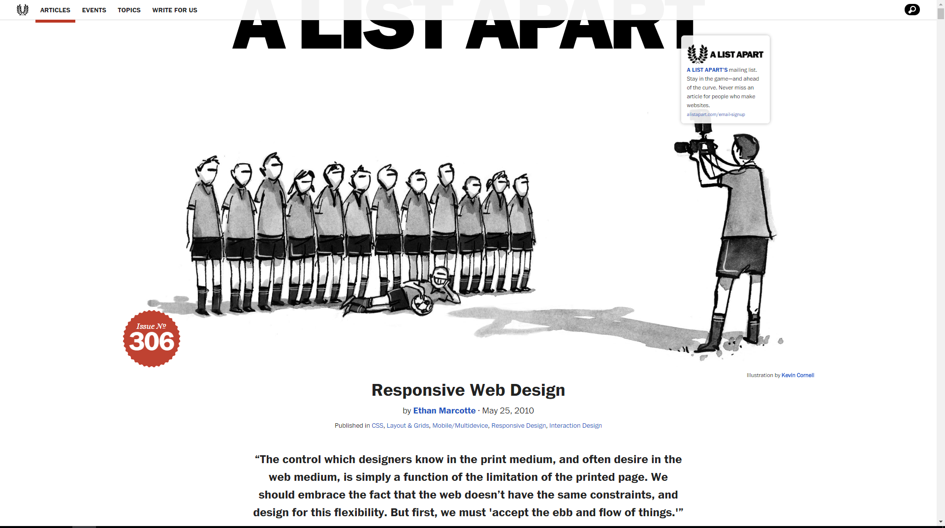
2 – RWD Examples
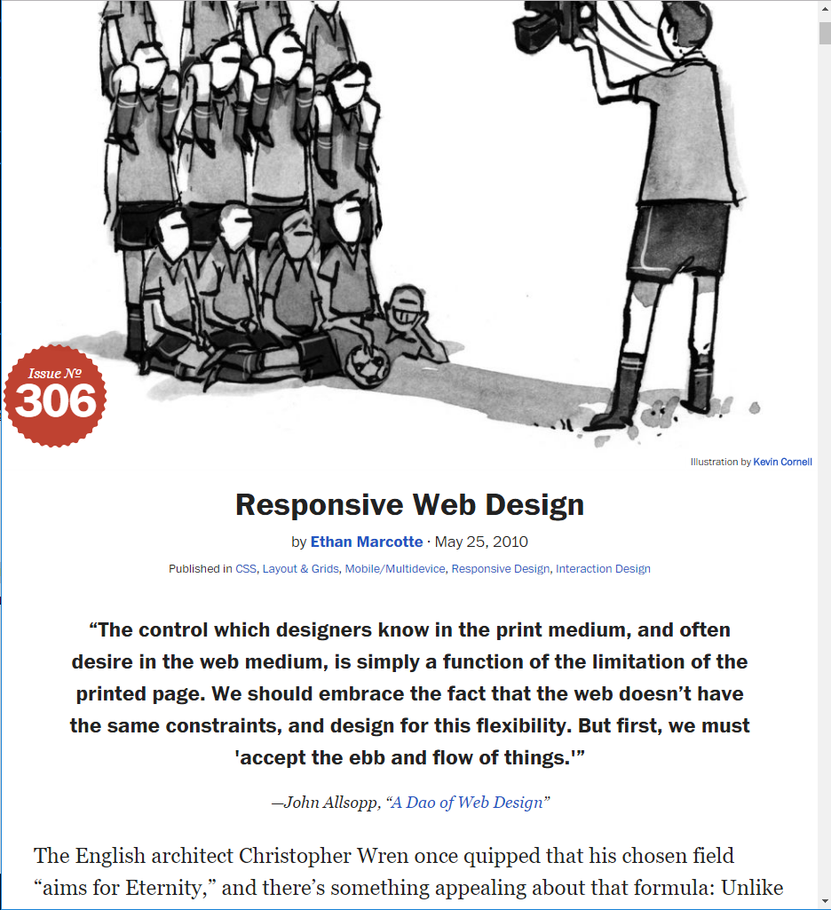
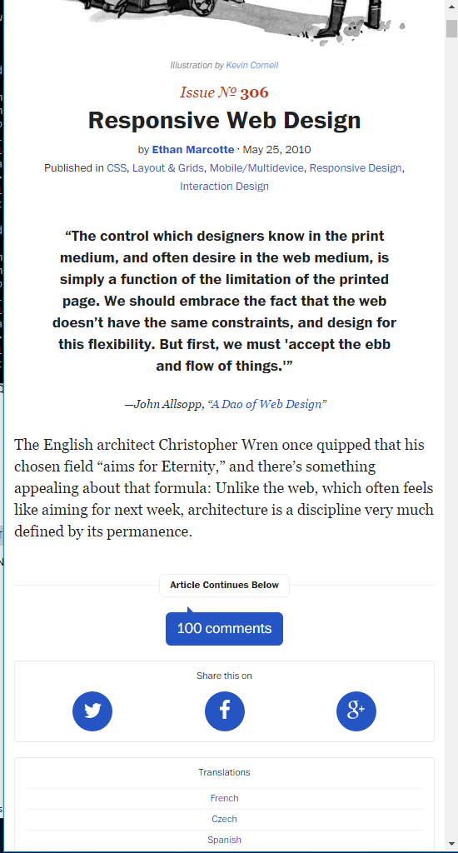
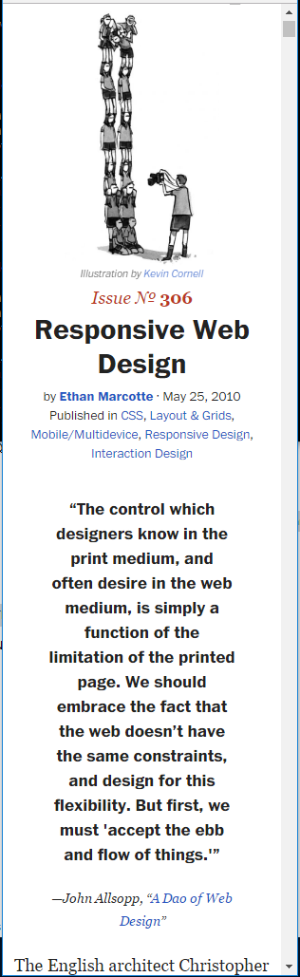
3 – RWD in practice

